Noah Meeker

CS 420

Lab 4 OOP

\*Disclaimer\*

This is by no means the best, cleanest code I have written. I did the best that I can according to what was provided in the prompt. Even with questions asked, either received no reply or did not help the understanding.

Following along with the prompt, the code I wrote starts up and asks the user to state what they would like to do. Based in the user’s input, the code will either take in the needed info to add a new employee to the database, info for the month’s sales, or printout the requested report. With these printouts, the user will be given the option for the reports to be printed out to a .txt file. The one downside to this implementation is that once the program is terminated, the database is lost. In the case of a negative turnout, it would be taken out of the total sales generated which would eat away at the owner’s and chefs’ take-home percentage. Otherwise, their salaries are not affected. When looking at the waiter’s tips, the program will print out the total amount of tips the waiter has made since being added to the database.

When inserting the employee’s information, the program will ask for certain information.

* First Name
* Middle Initial
* Last Name
* ID (any integer number)
* Salary

They will then be asked certain info regarding their position.

* Owner/Chef
  + Percentage (type 70 for 70%. Not 0.70)
* Waiter
  + Years at Company

When giving info on the month’s sales, the program will ask for the month’s total profit and tips made by each waiter.

There is no type checking or parameter checking. An improper input can cause the program to crash or give an incorrect output. Below are screenshots of the program:

Enter Waiter:

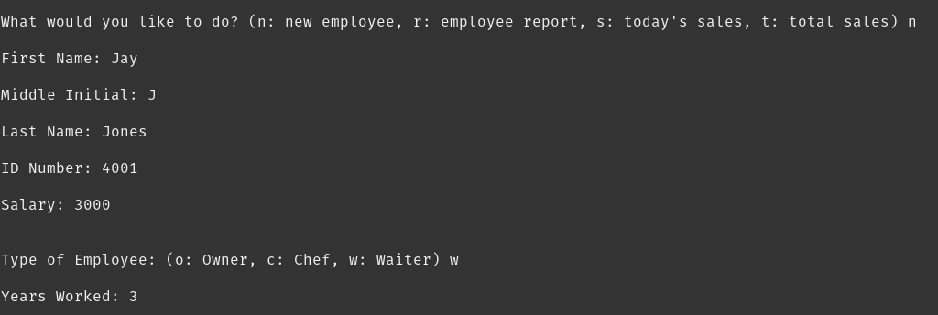 Enter Chef:

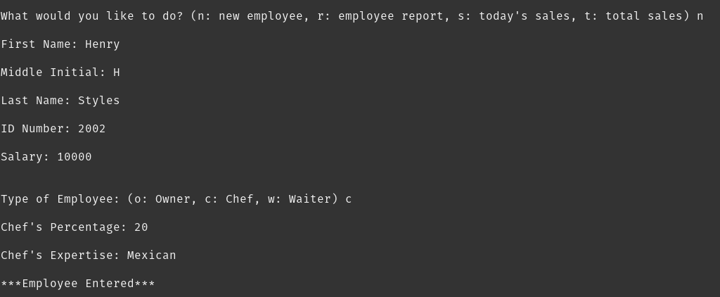 Enter Owner:

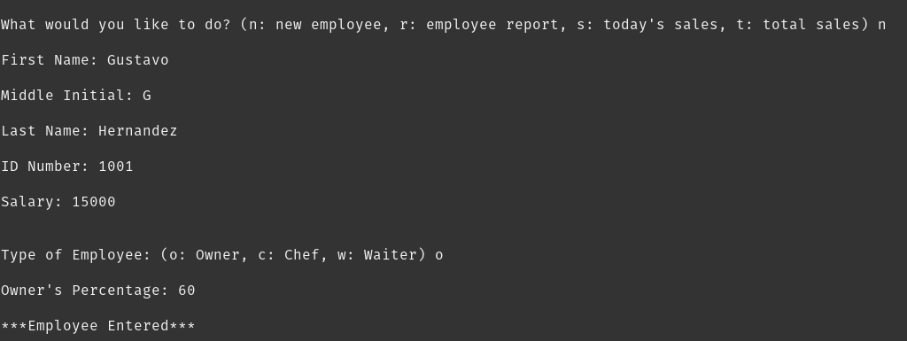

Print Employee’s:

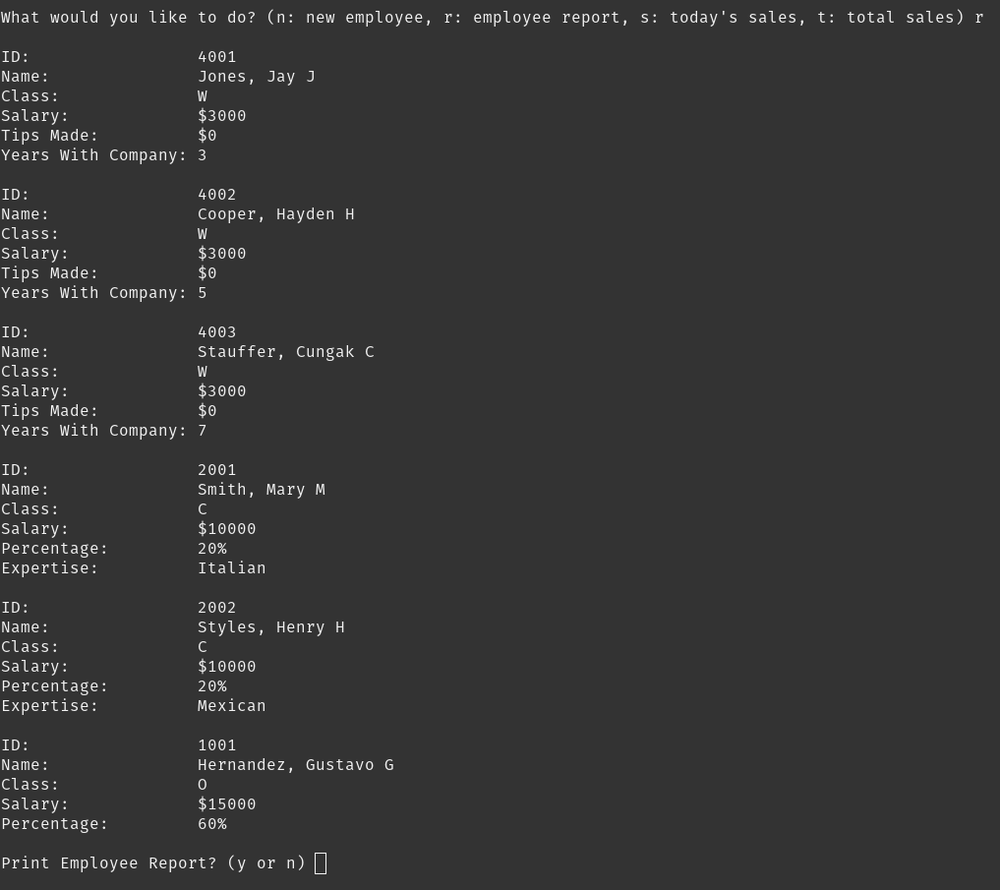

Enter Month’s Sales:

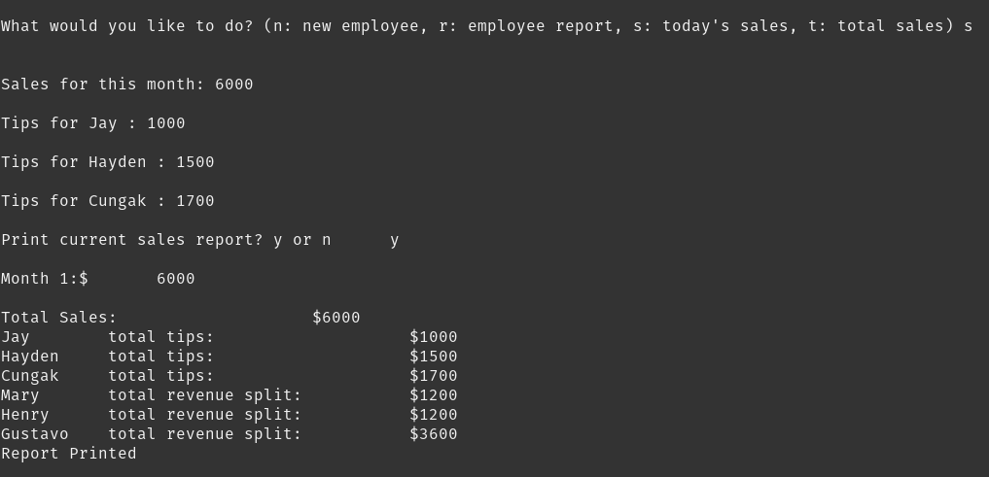 Print Total Sales:

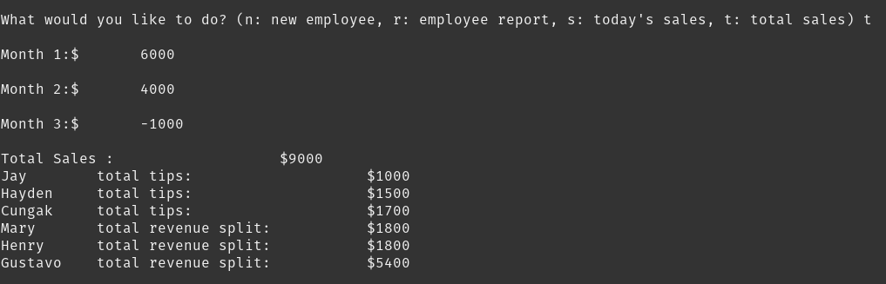 Attached to the submission will be the employee.txt and report.txt file from this example.